**DETAILED PROCEDURE FOR REPLACING HOT END**

The following procedure defines in detail the appropriate steps for replacing the hot end of your printer. Please read the entire procedure prior to attempting to replace the hot end. If you have any questions regarding these instructions please contact technical support via our ticketing system at the following link: [www.inventorcloud.net](http://www.inventorcloud.net)

**I. PREPARATION**

1. **Replacement Parts Needed:**

* E3D hot end with hot end, fan and thermistor wires attached, mounted in new extruder bottom
* New z-axis limit switch end stop

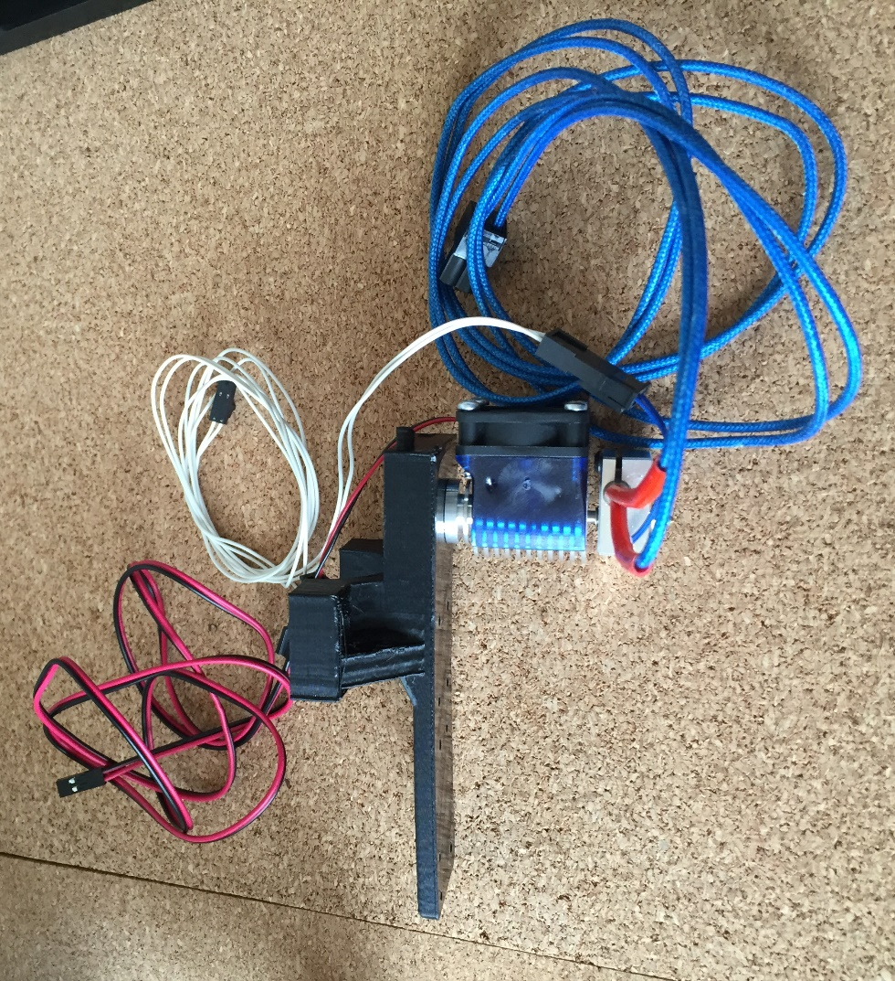

**E3D replacement hot end**

1. **Tools Required:**

* M3 Allen wrench
* M2.5 Allen wrench
* Needle nose pliers
* Wiring tool

1. **Parts to Be Removed and Returned to AST2:**

* Version 2 hot end attached to old extruder bottom
* Old z-axis limit switch end stop
* Old hot end wire
* Old thermistor wire
* Old fan wire with capacitor break out board, if present on your printer model
* Fan wire retainer, if present on your printer model
* HOT! sign

1. **Remove filament from hot end. Wait for hot end to cool down completely prior to continuing.**

Please refer to Section IV of the INVENT3D Printer Operating Instructions and Troubleshooting Guide, which can be found at the following link:

<http://www.inventorcloud.net/invent3d-instructions/>

1. **Ensure the printer is not powered on.**

If the printer power cable is connected to an outlet, disconnect it. Disconnect the power cable at the rear of the printer.

1. **Raise print board.**

Rotate the lead screw knob to raise the print board to just below the hot end.

1. **Remove top cover of printer.**

Lift the top cover off of the printer to expose the RAMBo board and wiring. Set the top cover aside as it will be replaced in a later step.

1. **Remove front cover of printer.**

Lift the front cover with LCD screen attached out of the slots that it sits in and set it on the table in front of you.

1. **Remove the printer’s right side cover.**

The right side cover is on your right hand side when facing the front of the printer. Unscrew the four thumbscrews that attach the right side cover to the right side frame and set them aside with the top cover to be replaced in a later step. Pull the right side cover off of the printer to expose the right side wire bundle. Set the right side cover aside with the parts to be replaced in a later step.

1. **Remove all zip ties on the right side wire bundle.**

Remove the two zip ties on the extruder top, one zip tie below the x-axis limit switch, one zip tie below the x-axis motor, and one zip tie on the right side of the RAMBo board. Set zip ties aside with the parts to be replaced in a later step.

1. **Remove the wire sleeve from the right side wire bundle.**

Pull the wire sleeve off of the wires on your right hand side. Set aside the wire sleeve with the parts to be replaced in a later step.

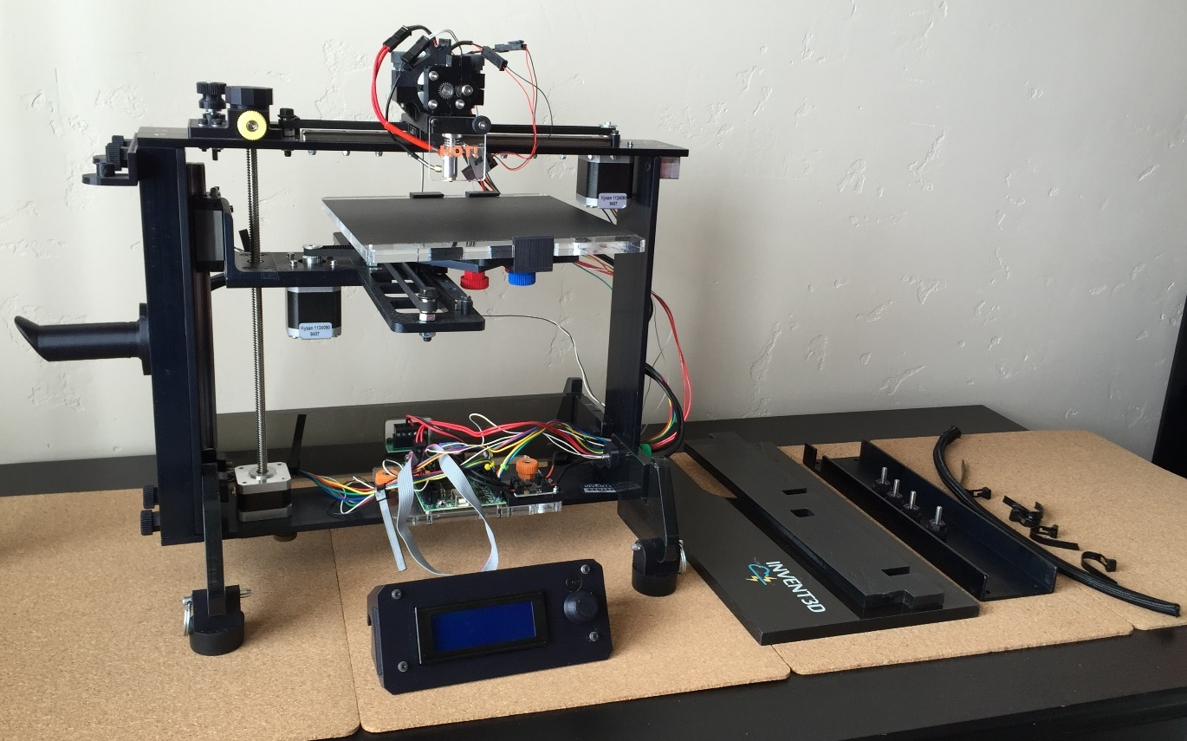

**Zip ties and wire sleeve removed *(Steps 10 & 11)***

**Right side cover removed *(Step 9)***

**Top cover and front cover removed *(Steps 7 & 8)***

**Print board raised *(Step 6)***

**II. DISCONNECT WIRING**

1. **If your RAMBo board has a fan wire retainer, detach the fan wire retainer from the RAMBo board mounting plate.**

The fan wire retainer is made of black plastic and is glued to the RAMBo board mounting plate. Detach the fan wire retainer breaking it off with a pair of pliers. Set the fan wire retainer aside to be returned to AST2.

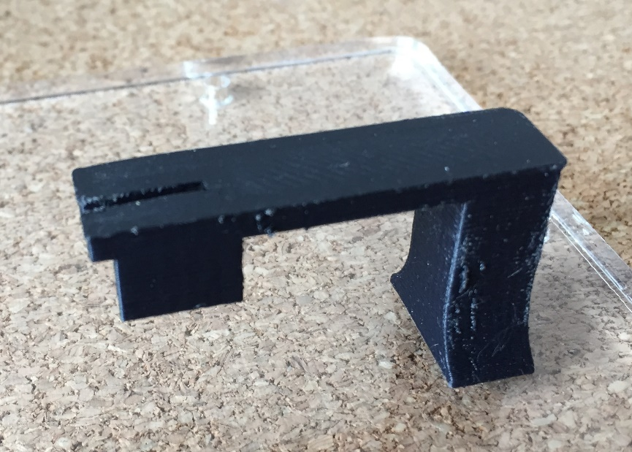

**Fan wire retainer attached to RAMBo mount**

1. **Disconnect the hot end wire, the fan wire, and the thermistor wire from the hot end at the quick disconnect near the extruder motor.**

Locate the three wire quick disconnects near the hot end. Disconnect the red hot end wire, the red and black fan wire, and the white thermistor wire from the hot end.

1. **Disconnect the hot end wire from the RAMBo board.**

Locate the hot end wire connection on the RAMBo board. Check to see if the plug connector has a release lever. Disconnect the hot end wire plug from the RAMBo board, depressing the lever if needed. Set the hot end wire aside to be returned to AST2.

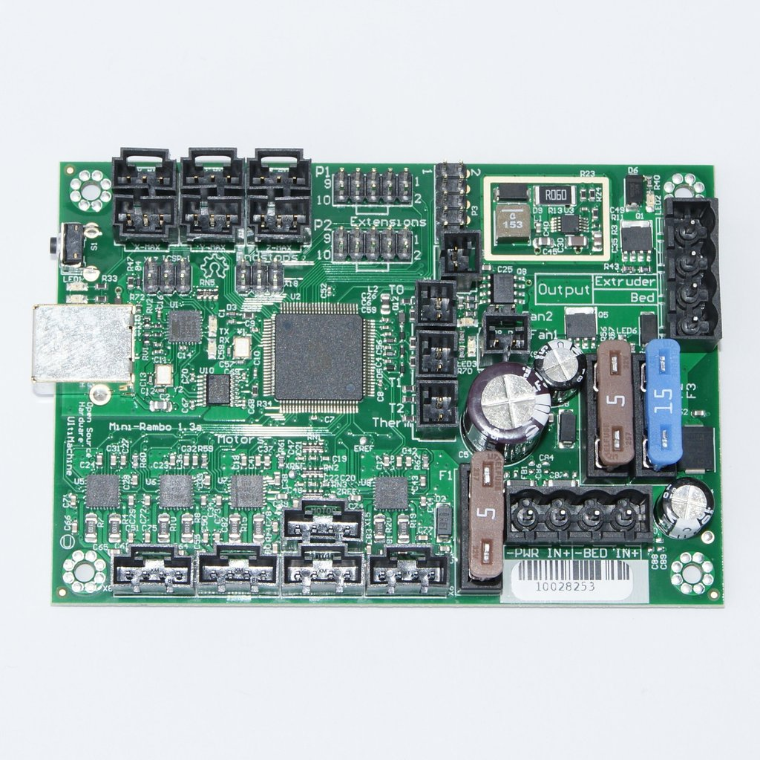

**Fan**

**Hot End**

**Thermistor**

**PRINTER REAR**

**PRINTER FRONT**

1. **Disconnect the thermistor wire from the RAMBo board**

Locate the thermistor wire connection on the RAMBo board. Check to see if the plug connector has a release lever. Disconnect the thermistor wire plug from the RAMBo board, depressing the level if needed. Set the thermistor wire aside to be returned to AST2.

1. **Disconnect the fan wire from the RAMBo board, removing the breakout capacitors if needed.**

Locate the fan wire connections on the RAMBo board. If you see that the fan wires are connected to a capacitor breakout board, remove the capacitor breakout board by unscrewing its mounting screw. Check to see if the fan wire plug connectors have a release lever. Disconnect the fan wire plugs from the RAMBo board, depressing the levers if needed. Set the fan wire with breakout capacitors, if present, to be returned to AST2.

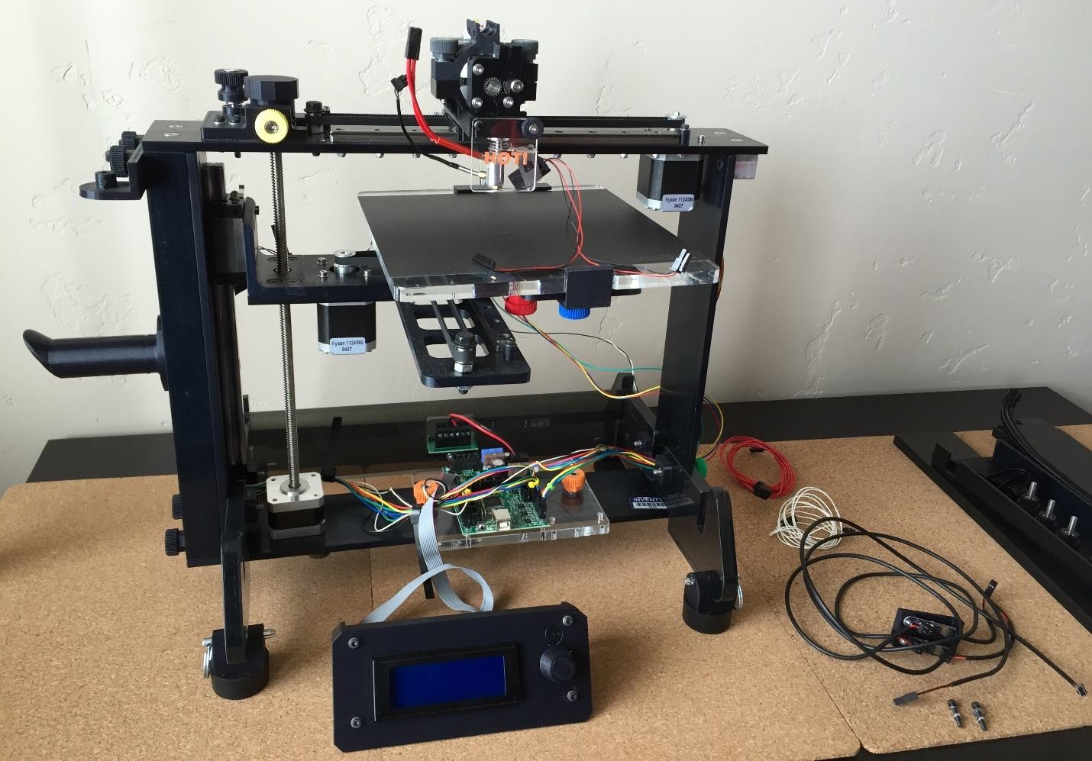

**Fan wire and breakout capacitors removed *(Step 5))***

**Thermistor wire removed *(Step 4)***

**Hot end wire removed *(Step 3)***

**III. REMOVE OLD HOT END**

1. **Remove the extruder top.**

Loosen and remove the two silver thumbscrews on either side of the extruder top that attach the top to the extruder bottom. Set the two silver thumbscrews aside to be replaced in a later step. Remove the extruder top from the extruder. Set the extruder top aside to be replaced in a later step.

1. **Remove the extruder motor.**

Remove the extruder motor with wire attached. Set the extruder motor on the print board, which should be raised up to just below the hot end. Take care not to knock off the extruder motor from the print board when performing subsequent steps.

1. **Remove the thumbscrew at front of extruder bottom and HOT! sign.**

Loosen and remove the small thumbscrew at the front of the extruder bottom that crosses the hot end mounting slot. Set the small thumbscrew aside with the parts to be replaced in a later step. Remove the HOT! sign from the front of the extruder bottom and set aside with the parts to be returned to AST2.

1. **Detach the extruder bottom with hot end attached from the x-axis rail carriage and belt.**

Remove the two M3 x 18 screws and washers closest to the back of the printer that connect the extruder bottom to the x-axis belt clamp. Set the screws and washers aside with parts to be replaced in a later step. Remove the remaining four M3 x 12 screws with washers that connect the extruder bottom to the x-axis rail carriage. Set the screws with lock washers aside with the parts to be replaced in a later step. Note that the two longer screws attach the extruder bottom to the belt and the four shorter screws attach the extruder bottom to the rail carriage. Remove the extruder bottom with hot end attached.

1. **Detach the x-axis limit switch from the extruder bottom.**

Remove the M2.5 x 18 screws, washers, and nuts that attach the x-axis limit switch to the extruder bottom. Use needle nose pliers to assist in removing the nuts. Set the limit switch on the print board next to the extruder motor; do not disconnect the wire from the limit switch. Set aside the screws, washers, and nuts with the parts to be replaced in a later step. Set aside the old extruder bottom with hot end attached to be returned to AST2.

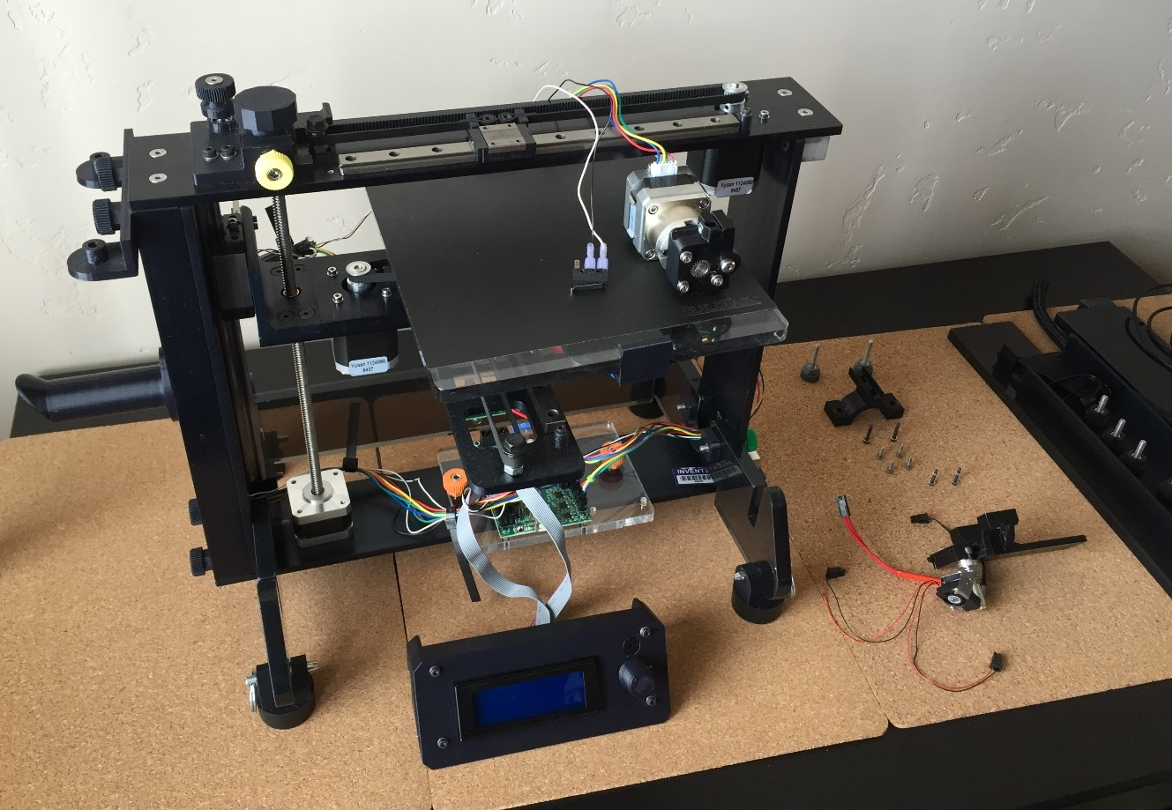

**Limit switch removed and set on print board *(Step 5)***

**Extruder bottom and hardware removed *(Steps 3, 4 & 5)***

**Extruder removed and set on print board *(Step 2)***

**Extruder top removed *(Step 1)***

**IV. ATTACH NEW HOT END**

1. **Attach the x-axis limit switch to new extruder bottom with hot end attached.**

Locate the new extruder bottom in the package of replacement parts. Align the holes in the body of the limit switch with the mounting holes in the new extruder bottom; the limit switch lever should be pointing toward the hot end and the white wire should be on the outside. Insert the two M2.5 x 18 screws and washers removed in the previous step through the top of the extruder bottom and into the limit switch. Tighten the screws to lock the limit switch in place. Note that the right screw will never become completely tight, however the limit switch will still be fixed in place. Tighten the M2.5 nuts onto the ends of the screws, using needle nose pliers to assist as needed.

1. **Attach the extruder bottom to the x-axis rail carriage.**

Locate the four M3 x 12 screws (the shorter screws) with washers previously removed from the old extruder bottom. Align the four mounting holes in the x-axis rail carriage with the corresponding holes in the new extruder bottom. Insert the two middle screws with washers through the extruder bottom and into the carriage, tightening by hand first and finishing with an Allen wrench. Insert the two front screws with washers and tighten slowly and carefully with an Allen wrench, ensuring that the screws do not become cross-threaded.

1. **Attach the extruder bottom to the x-axis belt.**

Locate the two M3 x 18 screws (the longer screws) and washers previously removed. Slide the extruder bottom on the rail carriage laterally as necessary to align the belt clamp mounting holes with the corresponding holes in the extruder bottom. Insert the two M3 x 18 screws with washers through the extruder bottom and into the belt clamp and tighten evenly, first by hand and then with an Allen wrench. You may need to press the belt clamp to the bottom of the extruder bottom so that the screws catch in the threads of the nuts embedded in the belt clamp. If an embedded nut in the belt clamp becomes dislodged, contact technical support for further assistance.

1. **Place extruder motor on extruder bottom and reattach extruder top.**

Place the extruder motor on the extruder bottom, ensuring that the extruder motor wire is facing up and the exit hole of the filament driving is facing down. Place the extruder top on the extruder motor with the wire trough pointed toward the rear of the printer. Insert the silver thumbscrews through the mounting holes on either side of the extruder motor and tighten evenly.

1. **Replace thumbscrew at front of extruder bottom**

Insert the black mini-thumbscrew through the hole at the front of the extruder bottom and tighten to lock the hot end into place. Do not reattach the HOT! sign.

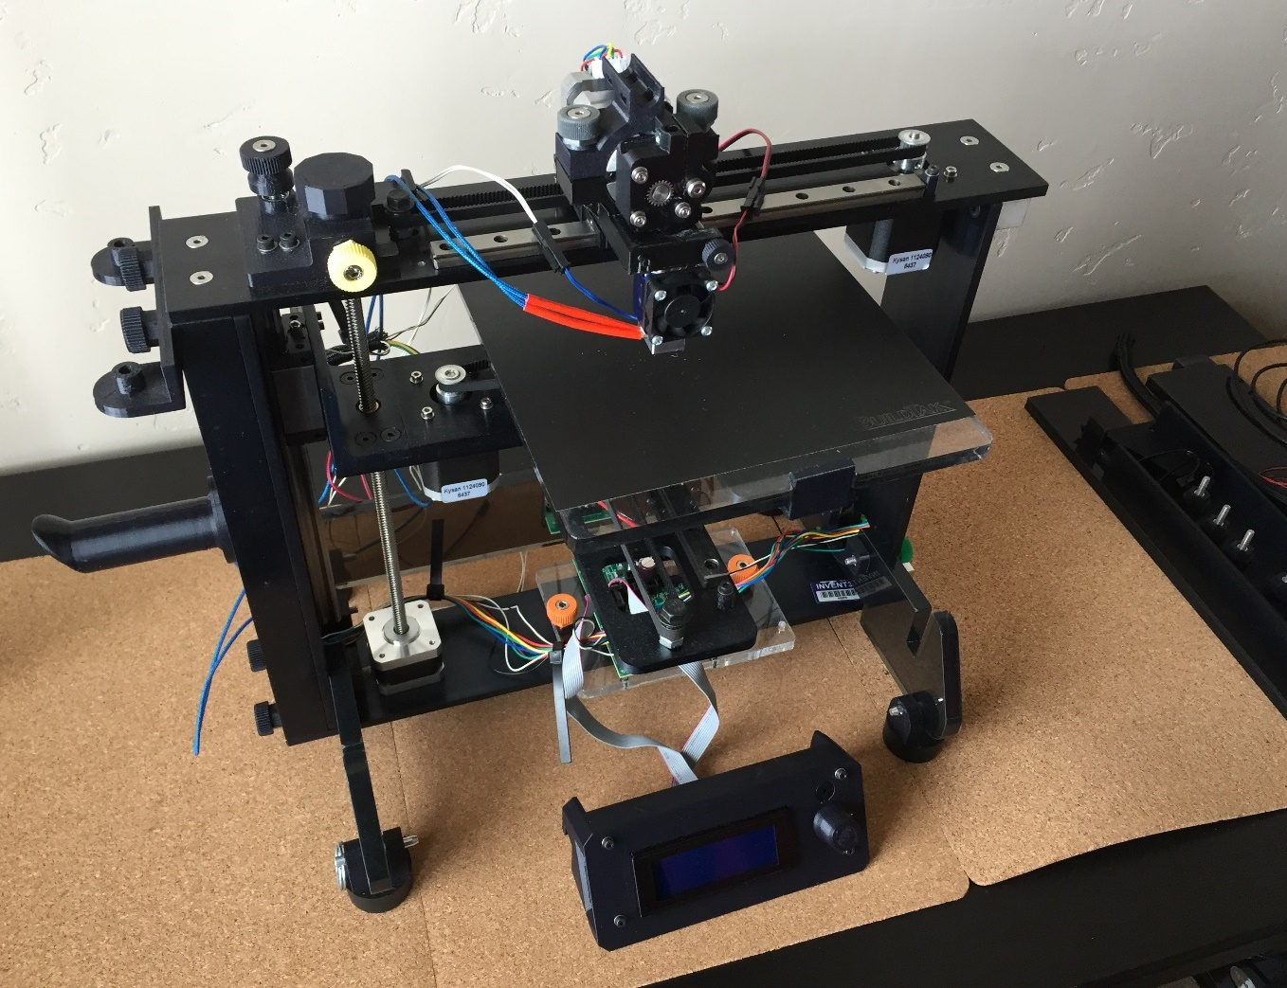

**Thumbscrew replaced *(Step 5)***

**Extruder motor and extruder top replaced *(Step 4)***

**New extruder bottom attached to carriage and belt *(Steps 2 & 3)***

**V. WIRING**

1. **Connect the hot end, thermistor, and fan wires to RAMBo board.**

Insert the hot end and fan wires through the hole in the right side frame. Connect the hot end, thermistor and fan wires in the appropriate locations on the RAMBo board. When inserting the fan wire to the RAMBo board, ensure that it is oriented correctly with the silver holes on the plug on your right hand side (away from the z-axis motor).



**Fan**

**Hot End**

**Thermistor**

**PRINTER REAR**

**PRINTER FRONT**

*WARNING: please verify that all wires are plugged into the appropriate locations prior to turning on printer as improper wiring can destroy the RAMBo board or otherwise harm the printer*

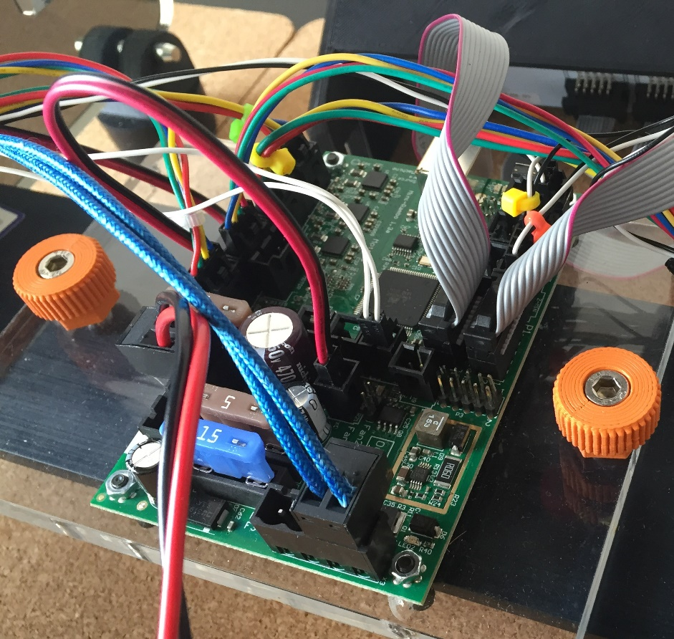

**Fan**

**Hot end**

**Thermistor**

1. **Insert the right side wire bundle wires into the wire sleeve.**

Turn the printer around so that you are facing the back of the printer. Push the hot end assembly to your right until it reaches the further point on the rail closest to the lead screw. Group the hot end wire, the fan wire and the thermistor wire together on the right hand side of the extruder motor. Group the hot end wire, fan wire, thermistor wire, extruder motor wire, and x-axis limit switch wire (do not include the x-axis motor wire) together in one hand near where they pass through the printer side frame. Place the group of wires into the slot of the wire installation tool, then close the tool around the wires. The white piece of the installation tool should be in your hand. Put the tip of the tool into one end of the wire sleeve. Pull the wiring tool through the length of the wire sleeve. Open the tool and remove the wires. Pull the extruder motor wire and x-axis limit switch wire out of the top of the wire sleeve, approximately 4 to 5 inches. Slide the wire sleeve up near the quick disconnects. Pull the wires from bottom of the wire sleeve to remove excess slack. Re-insert limit switch and extruder motor wires by hand until 2 to 3 inches of wire is exposed.

Please refer to the following link for instructions regarding use of the wiring tool: <https://www.youtube.com/watch?v=XBbaQ6HbTrQ>

1. **Replace zip ties near the extruder motor.**

Replace the zip ties around the wire sleeve at the trough on the extruder top. Place a zip tie just below the point at which the extruder motor wire and x-axis limit switch wire enter the wire sleeve.

1. **Insert the x-axis motor wire into the wire sleeve and replace zip tie.**

Push the x-axis motor wire by hand into the wire sleeve from the point where the wire sleeve passes the x-axis motor until the wire leaves the end of the wire sleeve. There should be 1 to 2 inches of wire exposed and 1-2 inches in sleeve. Place a zip tie around the wire bundle at the point where the x-axis motor wire enters the sleeve.

1. **Replace the zip tie close to the RAMBo board.**

Place a zip tie around the wires between the right side frame and RAMBo board.

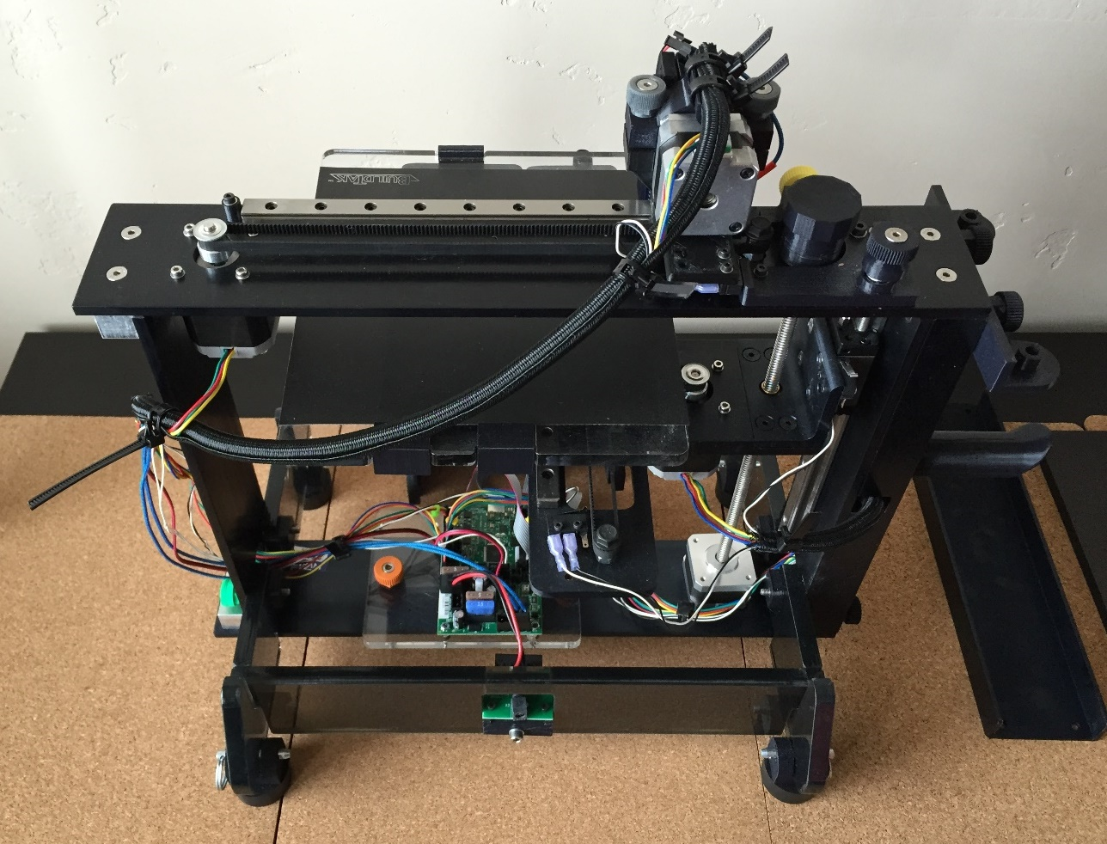

**Hot end assembly pushed far right *(Step 2)***

**Zip tie near RAMBo board *(Step 5)***

**X-axis motor entry point and zip tie *(Step 4)***

**Zip ties replacement locations near extruder motor *(Step 3)***

**VI. REPLACE COVERS**

1. **Replace right side cover.**

Orient the right side cover so that the wire sleeve retainer is on the upper side of the cover and facing the rear of the printer. Push the right side cover onto the connector blocks on the right side frame, ensuring wire bundle passes through the wire sleeve retainer in the top rear of the side cover. Approximately .5 inches of the wire sleeve should be covered by the side cover. Insert black thumbscrews into the four holes at each corner of the side cover and tighten.

1. **Replace front cover.**

Turn the printer around so that you are facing the front of the printer. Place the front cover with the LCD attached into the mounting slots on the sides of the printer. Ensure that the front cover sits flush in these slots.

1. **Replace top cover.**

Set the top cover onto the top of the front and rear covers, covering the RAMBo board and internal wiring.

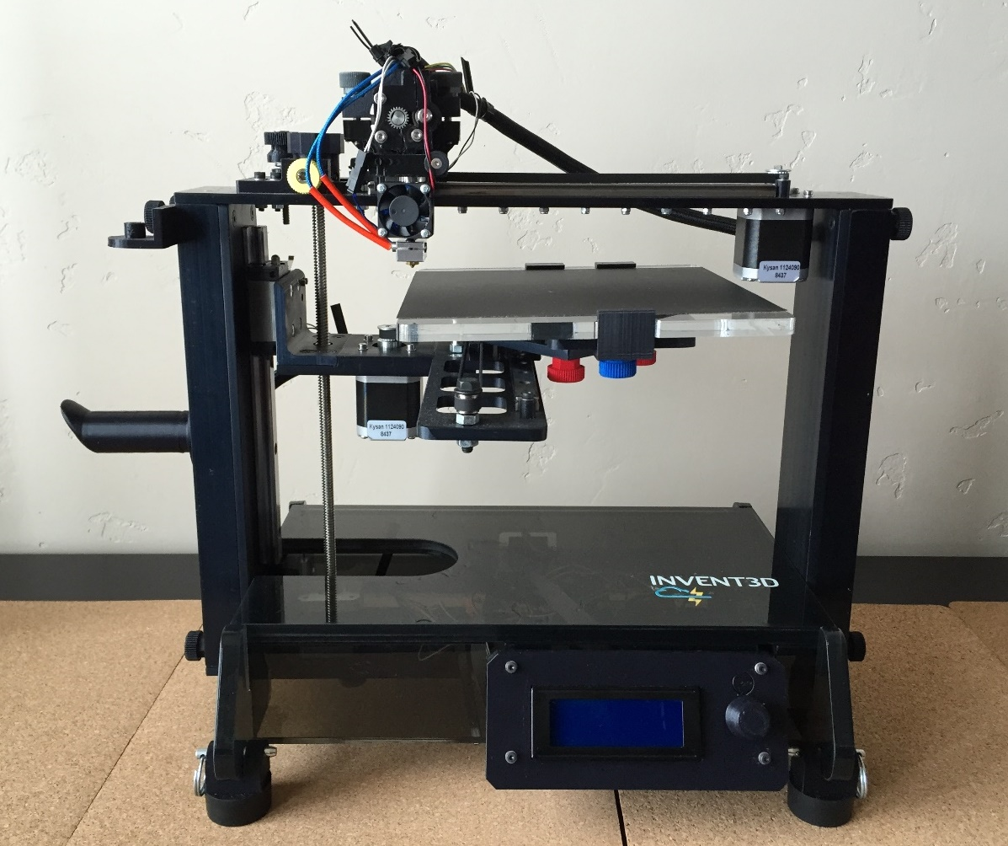

**Right side cover, front cover, and top cover replaced**

**VII. REPLACE Z-AXIS LIMIT SWITCH END STOP**

1. **Remove z-axis limit switch end stop and spring.**

Unscrew the old z-axis limit switch end stop with spring to remove it from the top of the printer frame. Remove the spring from the end stop and set it aside. Set aside the old x-axis limit switch end stop with the parts to be returned to AST2.

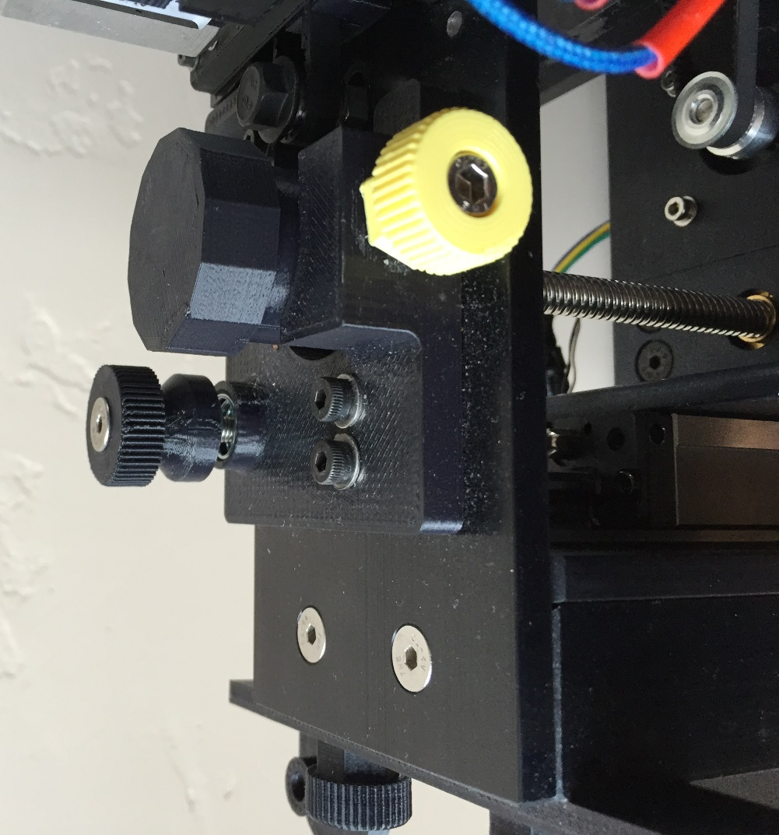

**Z-axis limit switch end stop to be replaced**

1. **Attach the new z-axis limit switch end stop.**

Place the spring on the new z-axis limit switch end stop and insert the new end stop in the appropriate location on the top left side of the printer.

**VIII. INSTALL NEW FIRMWARE**

Use of the new hot end by the printer requires installation of updated firmware. Do not attempt to use your printer with the new hot end without installing firmware first. Please follow the instructions for downloading and installing firmware at the following link:

<http://www.inventorcloud.net/invent3d-recall-information/>

Firmware version 3.2 – 32 (for E3D hot end with mini-RAMBo) should be installed.

**IX. CALIBRATION**

Follow procedure to level print board and calibrate z-axis limit switch distance. Please refer to Section IV of the INVENT3D Printer Operating Instructions and Troubleshooting Guide, which can be found at the following link:

<http://www.inventorcloud.net/invent3d-instructions/>

**X. RETURN ALL PARTS THAT WERE REMOVED AND NOT REPLACED TO AST2**

Ship the hot end with extruder bottom, hot end wire, fan wire (with capacitors if present), thermistor wire, fan wire retainer (if present), x-axis limit switch end stop, and HOT! sign to AST2 at the following address:

AST2

241 W Federal St

Youngstown, OH 44503

If desired, use the same box for return shipping that was used to send the replacement parts. Do not remove the hot end from the extruder bottom.