**QUICK START GUIDE FOR HOT END REPLACEMENT**

*Prior to beginning, ensure that filament has been removed from hot end and that the printer is not powered on. Please refer to the detailed hot end installation procedure if further guidance is required. If additional guidance is required beyond the detailed instructions, please use contact technical support via our ticketing system at the following link:* [*www.inventorcloud.net*](http://www.inventorcloud.net)

1. **Preparation**
   1. Raise print board to just below hot end
   2. Remove top cover
   3. Remove front cover
   4. Remove right side cover
   5. Remove all zip ties on right side wire bundle
   6. Remove right side wire sleeve

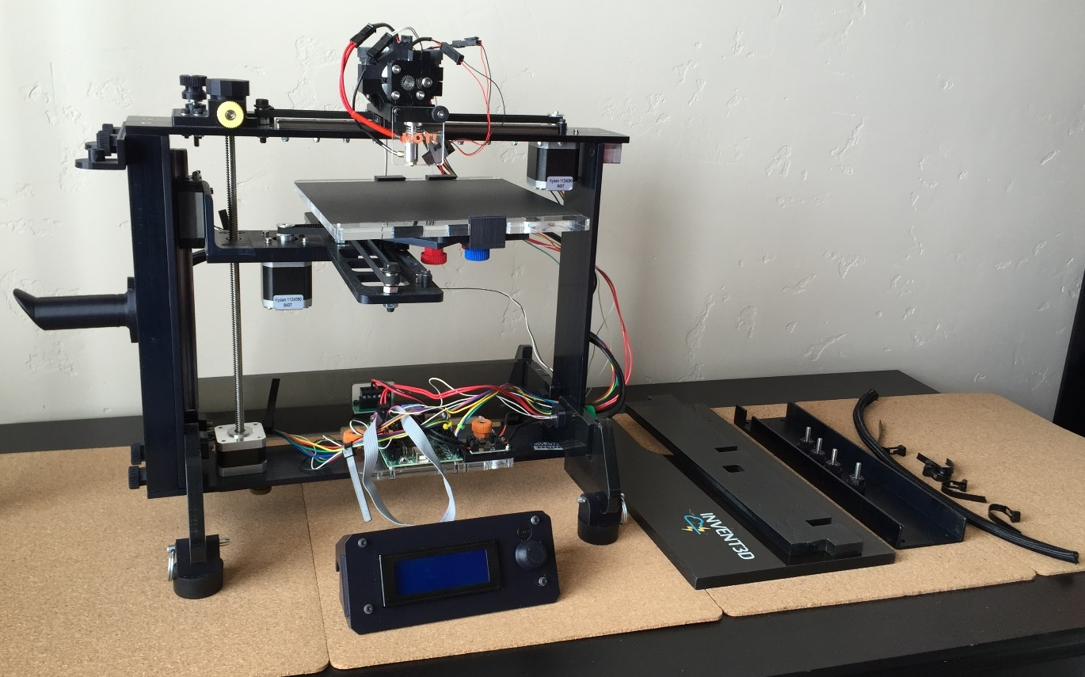

**Print board raised; top, front, and right side covers removed; and wire sleeve removed**

1. **Disconnect and hot end, fan, and thermistor wiring**
   1. Disconnect at hot end quick disconnects
   2. Disconnect from mini-RAMBo
   3. Remove breakout capacitors or break off fan wire retainer

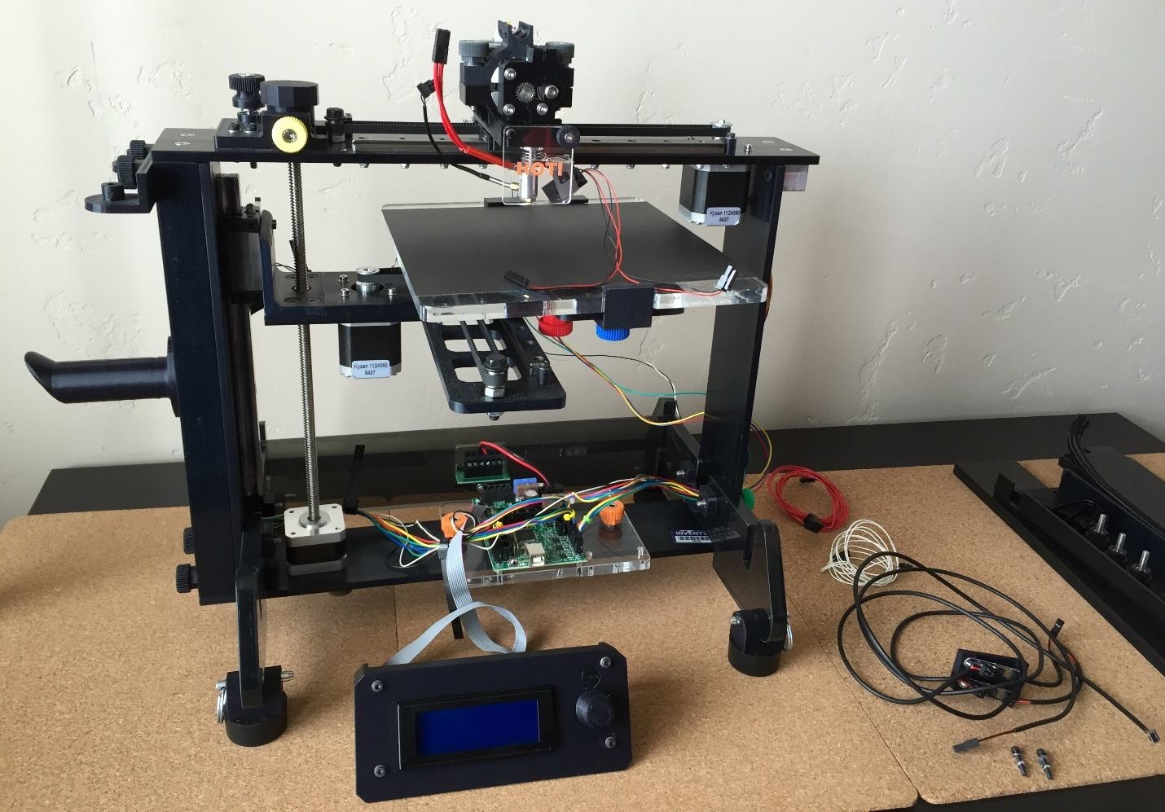

**Wiring disconnected**

1. **Remove old extruder bottom with hot end**
   1. Remove extruder top
   2. Remove extruder motor and set on print board
   3. Remove HOT! sign and black mini-thumbscrew
   4. Remove extruder bottom with hot end attached from carriage and belt
   5. Detach x-axis limit switch from extruder bottom

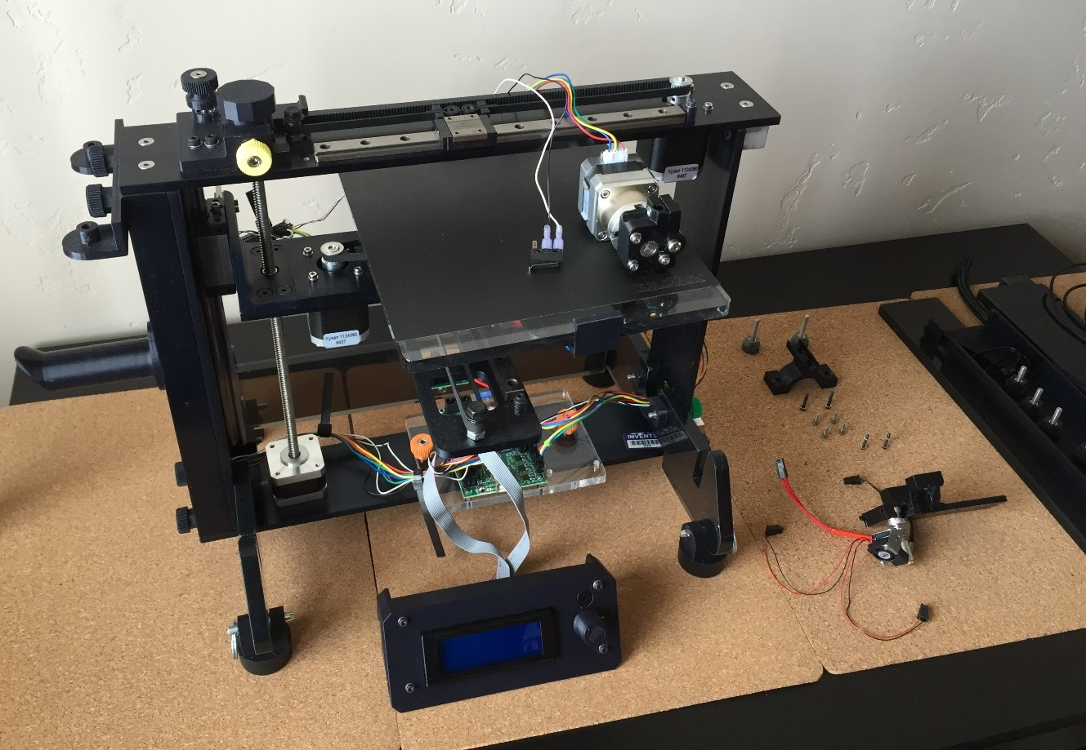

**Old extruder bottom and hot end removed**

1. **Attach new extruder bottom with hot end**
   1. Attach x-axis limit switch to new extruder bottom
   2. Attach new extruder bottom to carriage and belt
   3. Replace extruder motor and extruder top
   4. Replace mini-thumbscrew at front of extruder bottom

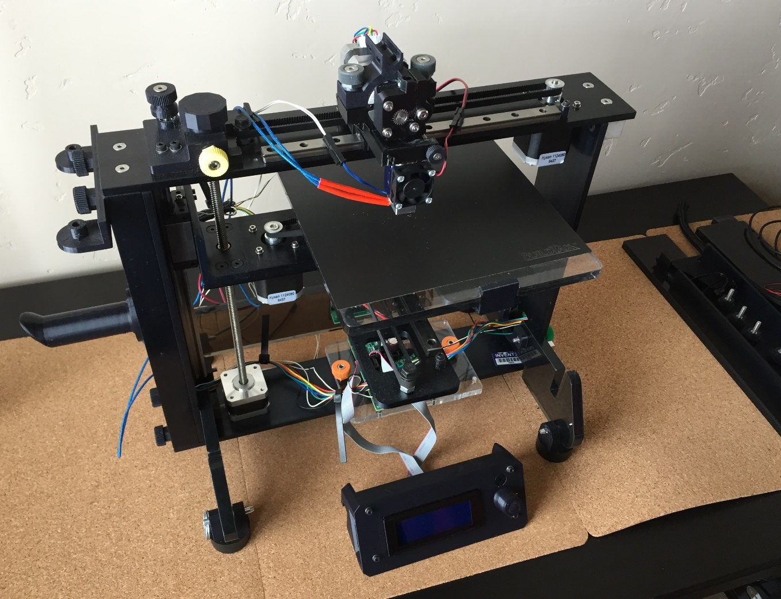

**New hot end and extruder bottom attached**

1. **Rewire the right side wire bundle**
   1. Pass the hot end, fan, and thermistor wires through the right side frame and connect them to the mini-RAMBo board

*WARNING: please verify that all wires are plugged into the appropriate locations prior to turning on printer as improper wiring can destroy the RAMBo board or otherwise harm the printer*

* 1. Replace wire sleeve using wiring tool (instructions for using the wiring tool can be found at <https://www.youtube.com/watch?v=XBbaQ6HbTrQ>)
  2. Replace zip ties

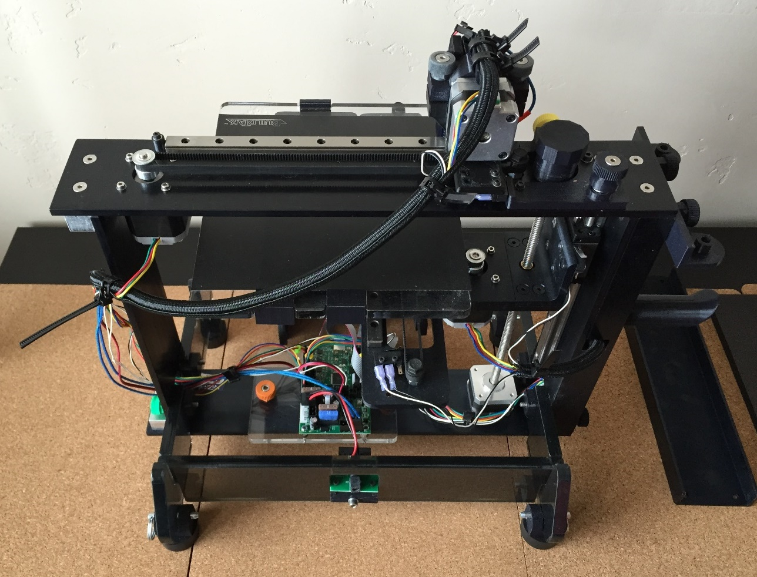

**Rewired right side wire bundle**

1. **Replace right side, front and top covers**
   1. Replace right side cover
   2. Replace front cover
   3. Replace top cover

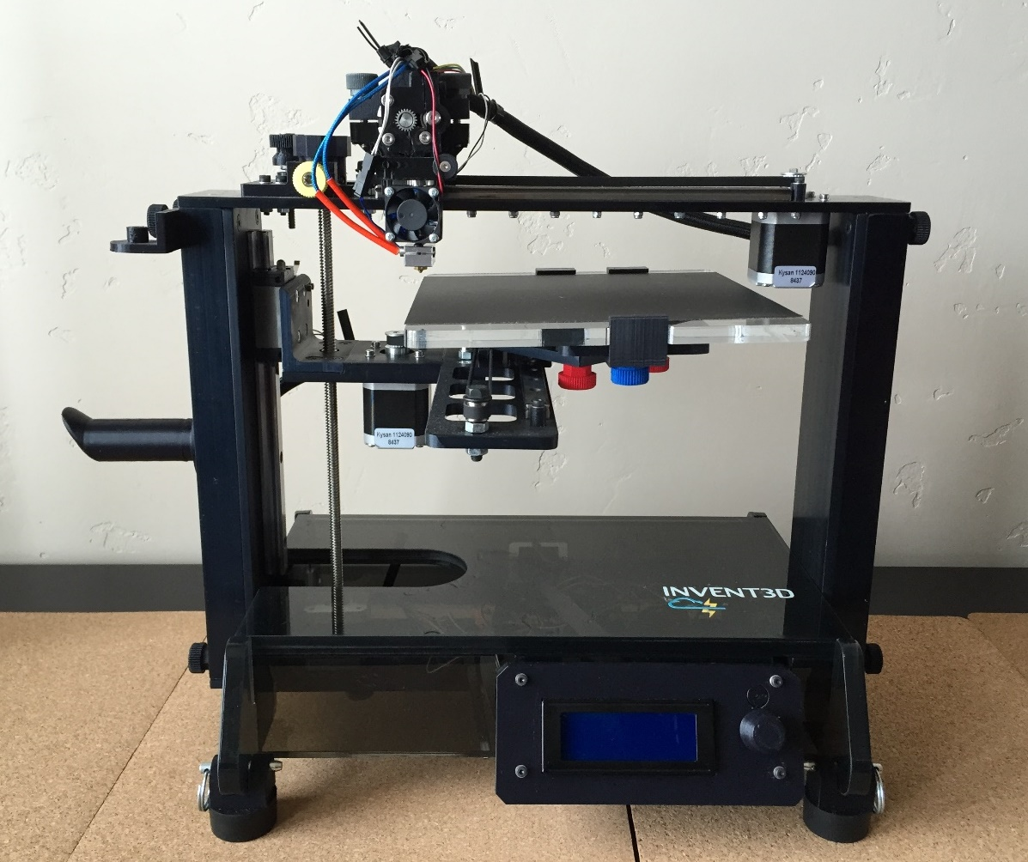

**Covers replaced**

1. **Replace z-axis limit switch end stop**
   1. Remove old end stop
   2. Place spring on new end stop and insert into frame

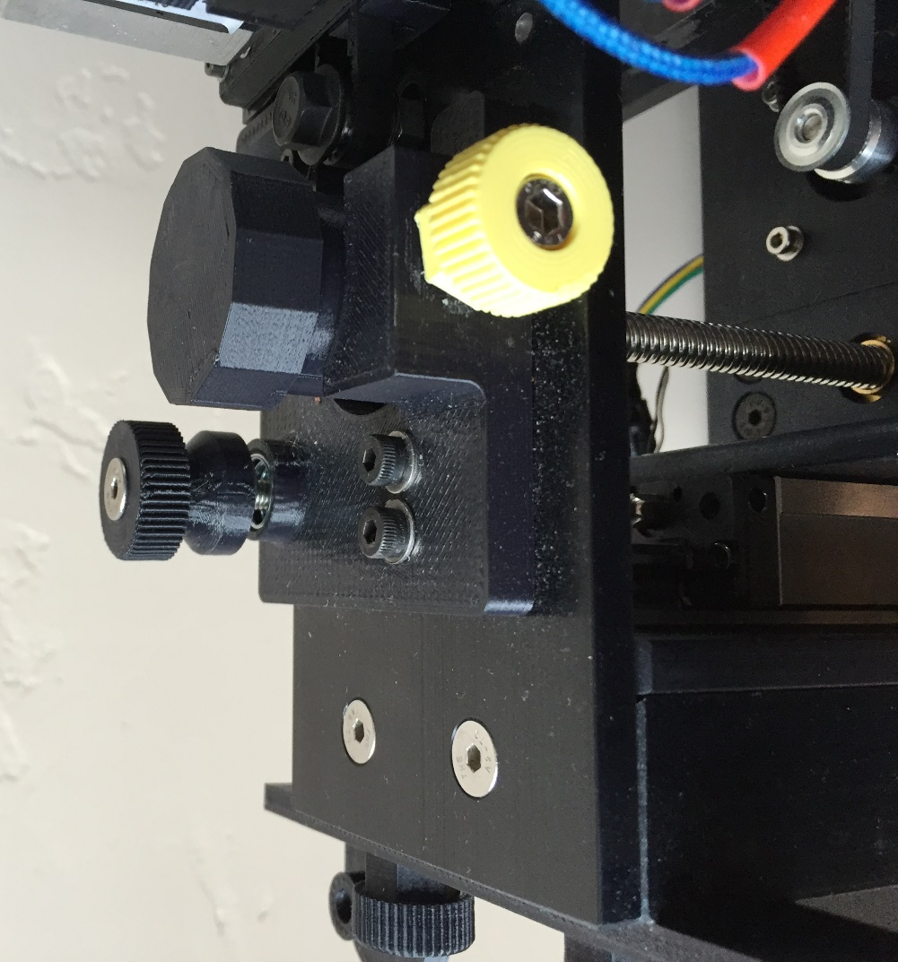

**Replaced z-axis limit switch end stop**

1. **Install new firmware**
   1. Follow procedure at <http://www.inventorcloud.net/invent3d-recall-information/>
   2. Firmware 3.2 – 32 (for E3D hot end with mini-RAMBo) should be installed
2. **Re-level print board and set z-axis limit switch distance**
   1. Follow procedure in Section IV at <http://www.inventorcloud.net/wp-content/uploads/2016/11/INVENT3D-Printer-Operating-Instructions-V6.pdf>
3. **Return all removed components that were not replaced, including the old hot end with extruder bottom, to AST2**
   1. Ship in shame box as replacement parts received
   2. Return to 241 W Federal St, Youngstown, OH, 44503